SIMATS ENGINEERING
ASSESSMENT TOOL 4

COURSE NAME: Artificial Intelligence COURSE CODE: CSA17

COURSE OUTCOME COVERED

CO2: Experiment search and game-solving techniques such as Greedy Search, A*, CSP, Minimax, and Alpha-Beta pruning with heuristic functions for solving complex AI problems efficiently. (BL3)

Assessment Tool Weightage: 40%

Duration: 1 Hour
QUESTIONS: 3 Total Marks:30

Annexure A
sDry Run Evaluation

Code of Conduct:

I G MADHAVA REDDY certify that this submission is my original work and that I have adhered to the guidelines specified for this assessment.
I understand that any violation of academic integrity rules will result in disciplinary action.

G MADHAVA REDDY
Signature of the student:
Annexure A
Dry Run Evaluation
1. Question 1 – Breadth-First Search (BFS)
Consider the following graph: A
/ \

B C
/ \ / \
D E F G

Task: Starting from node A, perform a Breadth-First Search (BFS). Complete the following table.

Iteration Queue Visited Node
1
2
3
4
5
6 7

Questions:

- Write the BFS traversal order.
- Show the queue contents after each iteration.

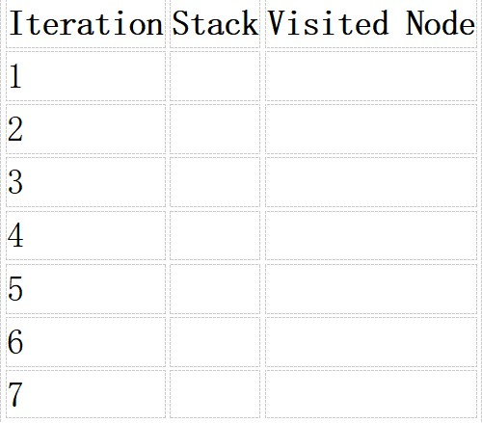
2. Depth-First Search (DFS) Using the same graph,
A
/ \
B C
/ \ / \
D E F G
Perform Depth-First Search (DFS) starting from A.
Complete the table.
3. Initial State :
1 3 6
5 0 2
4 7 8
Goal State :
1 2 3
4 5 6
7 8 0

Task
Trace Breadth-First Search (BFS) until the goal state is reached.
Fill in the table.
Iteration Current State Queue Before Expansion Queue After Expansion
1 2
3
4 5

Questions

- Which node is expanded in each iteration?
- How many states are generated in total?
- Write the complete solution path from the initial state to the goal state.
- Why does BFS always find the shortest solution in an unweighted 8-puzzle problem?

RUBRICS FOR CALCULATION

Criteria | Weightage (%) | Level 4 –  Exemplary (4) | Level 3 –  Proficient (3) | Level 2 –  Developing (2) | Level 1 –  Beginning (1)
Understandi ng of Search Problem | 20 | Clearly understands the search problem, initial state, goal state, and search strategy. | Understands the problem with minor misunderstandin gs. | Demonstrates partial understanding of the search problem. | Shows little or no  understanding of the search problem.
Criteria | Weightage (%) | Level 4 –  Exemplary (4) | Level 3 –  Proficient (3) | Level 2 –  Developing (2) | Level 1 –  Beginning (1)
State  Expansion and Dry Run Execution | 30 | Correctly traces every iteration, expands nodes accurately, and maintains the Queue/Stack/Priority  Queue without errors. | Performs most iterations correctly with  minor mistakes in state expansion or data structure updates. | Performs only some iterations correctly; several errors in tracing or node expansion. | Unable to correctly perform the dry run or expand states.
Application of Search Algorithm | 20 | Applies the selected algorithm  (BFS/DFS/UCS)  correctly, following all algorithmic rules. | Applies the algorithm correctly with a few procedural errors. | Applies only basic algorithm steps with noticeable mistakes. | Fails to apply the correct search algorithm.
Accuracy of  Solution Path | 20 | Identifies the correct traversal order/solution path and goal state with proper justification. | Solution path is mostly correct with minor errors. | Partially correct solution path; goal may not be reached correctly. | Incorrect or incomplete solution path.
Presentation and Logical Reasoning | 10 | Queue/Stack/Priority Queue updates, state diagrams, and explanations are neat, organized, and logically presented. | Presentation is clear with minor organizational issues. | Limited explanation and organization; reasoning is partially clear. | Poor presentation with unclear or missing reasoning.

Question 1: Breadth-First Search (BFS) Given Graph:
A
/ \
B C
/ \ / \
D E F G
BFS Dry Run
Iteration Queue Visited Node
1 A A
2 B, C B
3 C, D, E C
4 D, E, F, G D
5 E, F, G E
6 F, G F

7 G G
Answers
1. BFS Traversal Order
A → B → C → D → E → F → G
2. Queue after each iteration
- A
- B, C

C, D, E

D, E, F, G

E, F, G

F, G
7. G → Empty

Question 2: Depth-First Search (DFS)
DFS Traversal
Starting from A, visit the left child first.
Iteration Stack Visited Node
- A A
- B, C B
- D, E, C D
- E, C E
- C C
- F, G F
- G G
DFS Traversal Order
A → B → D → E → C → F → G

Question 3: 8-Puzzle BFS Dry Run
Initial State
1 3 6
5 0 2
4 7 8
Goal State
1 2 3
4 5 6
7 8 0
BFS Trace (Initial Expansions)
Iteration Current State Queue Before Expansion Queue After Expansion
- 136/502/478 [136/502/478] Generate 4 successor states Iteration Current State Queue Before Expansion Queue After Expansion
- Move Blank Up Remaining states Generate new successors
- Move Blank Down Updated queue Generate successors
- Move Blank Left Updated queue Generate successors
- Move Blank Right Updated queue Continue until goal is found
Note: The complete BFS tree for this 8-puzzle is very large. The question asks for the BFS trace; in an exam, you would continue expanding states level by level until the goal state is reached.
Answers
- Which node is expanded in each iteration?
  - Iteration 1 – Initial State
  - Iteration 2 – First generated state
  - Iteration 3 – Second generated state
  - Iteration 4 – Third generated state
  - Iteration 5 – Fourth generated state

- How many states are generated in total?
  - The initial state generates 4 successor states because the blank tile (0) is in the center.
  - The total number of generated states depends on how many levels are explored before reaching the goal.

- Complete Solution Path
Initial State
↓

Intermediate State(s)
↓

Goal State

1 2 3
4 5 6
7 8 0

4. Why does BFS always find the shortest solution?
BFS explores all states level by level. Since each move in the 8-puzzle has the same cost, the first time the goal state is reached corresponds to the minimum number of moves. Therefore, BFS always finds the shortest solution in an unweighted state space.

